1. **Created the Secret manager key**
2. Need to select the option as (Other type of secret) for test
3. Than given as name as vaseem-SM

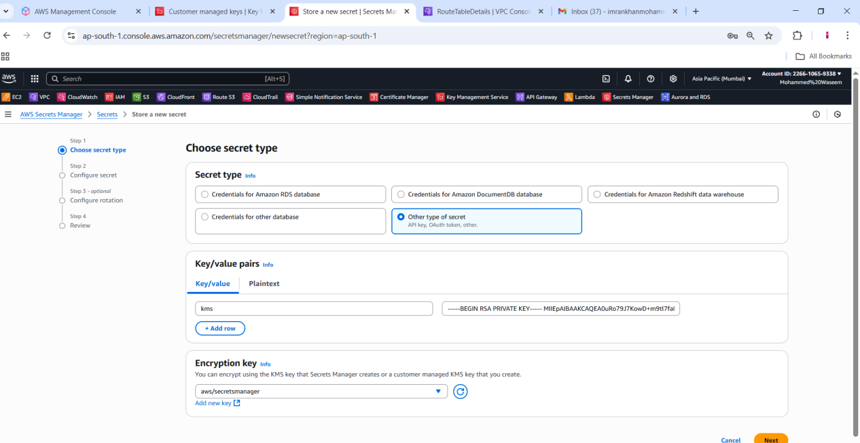

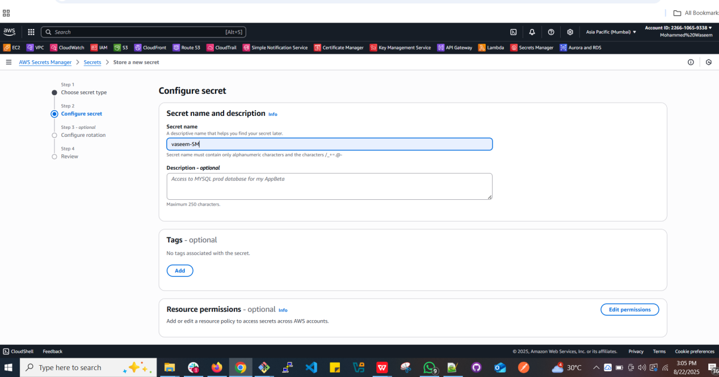

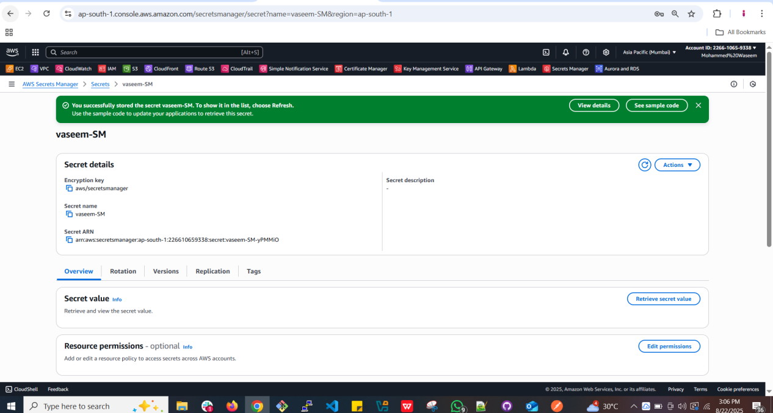

1. **Here we need to use the command**
2. Than using the below command we are listong the secrets manager keys
3. aws secretsmanager list-secrets
4. Than the secret list will appear

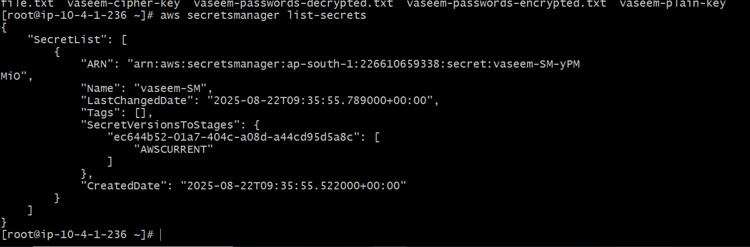

1. **Than need to give command**
2. aws secretsmanager get-secret-value --secret-id (Secret manager name)> vaseem-SM
3. It will show the keys

